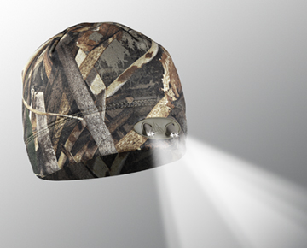
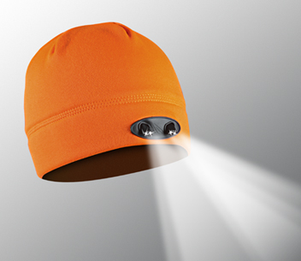
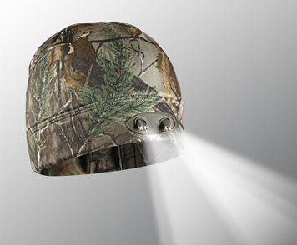
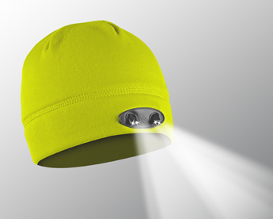
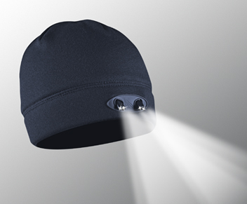
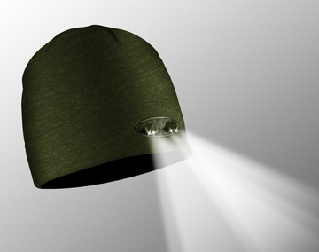
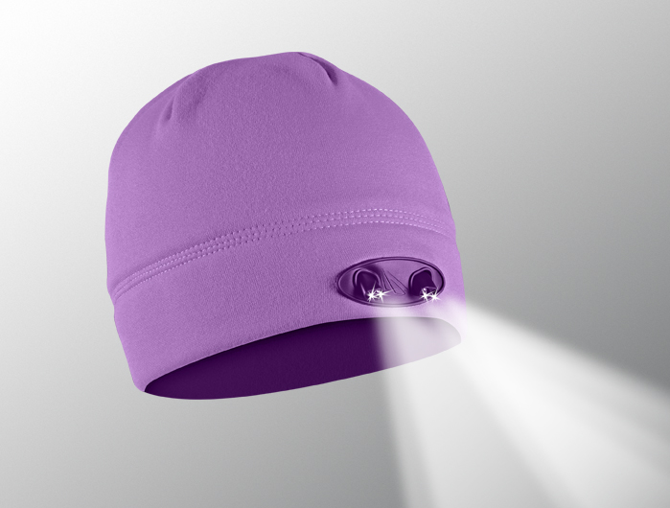
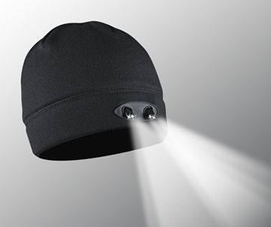
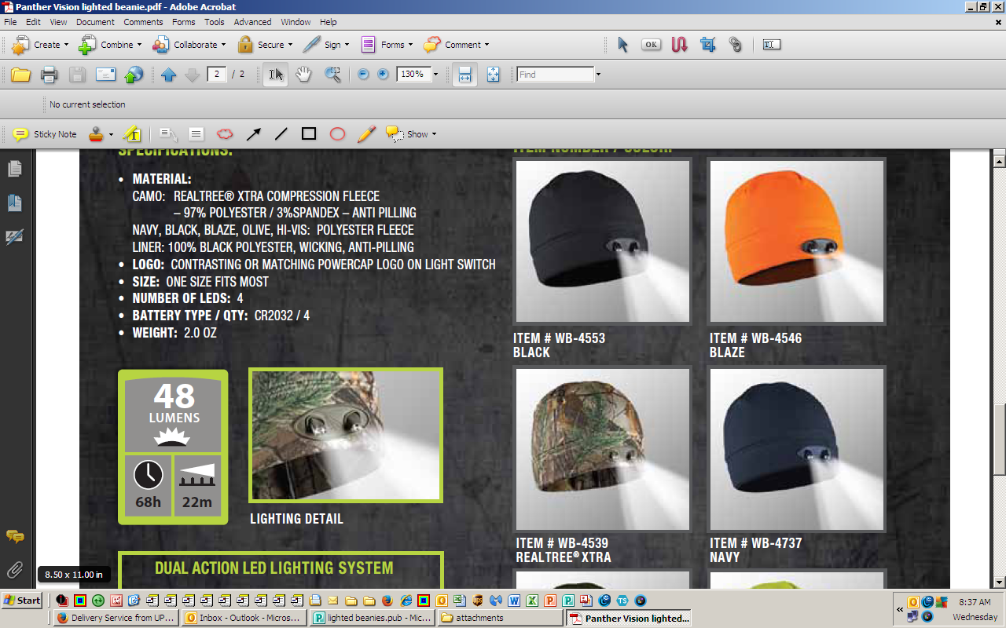
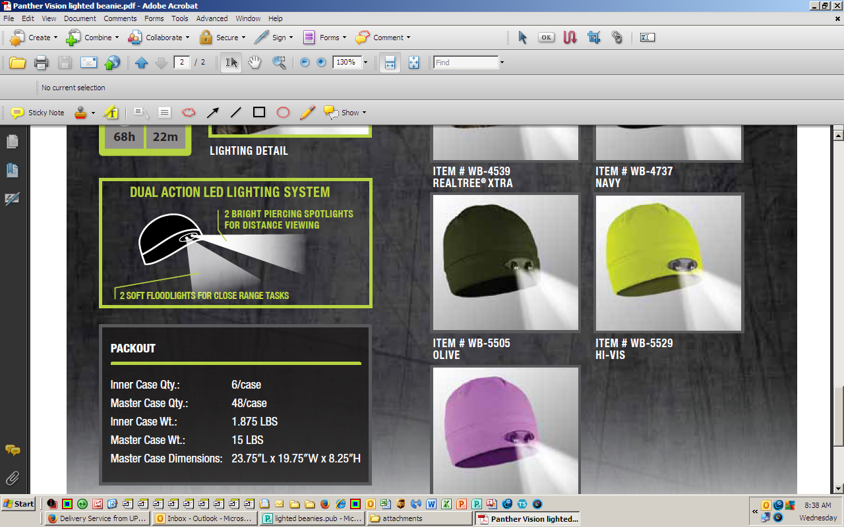
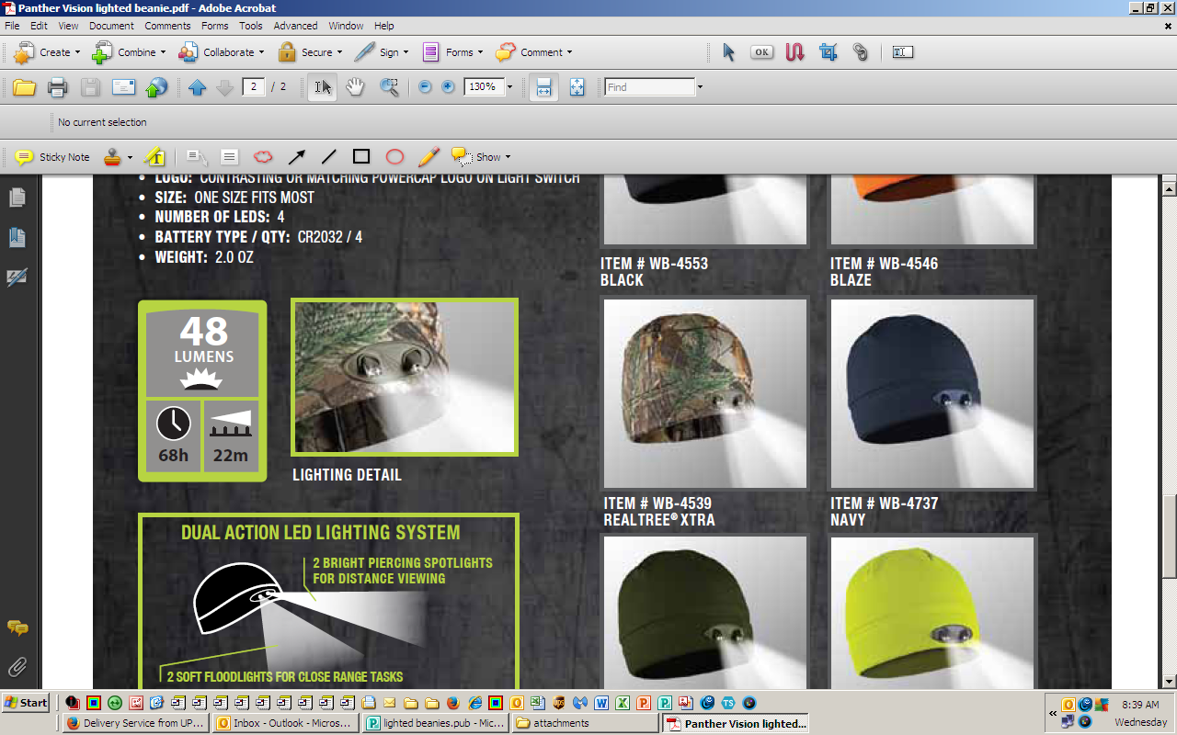
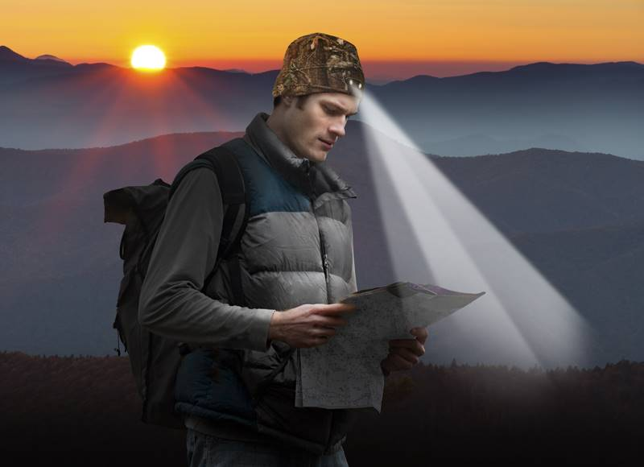
Lighting detail

VISIT OUR WEBSITE WWW.PANTHERVISIONPROMO.COM
TO SEE THE FULL LINE OF LIGHTED PRODUCTS
OR CALL 847.783.5900 x 116 FOR MORE INFORMATION

ILLUMINATING BEANIES
Keep you warm, dry & light your way
We have you covered with over 60,000
pieces in stock and on order for the holidays
BLACK WB-4553
ORANGE WB-4546
REALTREE XTRA WB-4539
NAVY WB-4737
OLIVE WB-5505
HI-VIZ WB-5529
ORCHID WB-5628
POWERCAP® 35|55 LED LIGHTED BEANIE

POWERCAP® LED Lighted Beanie Hats
combine Patent Pending Ultra Bright LED technology with a premium anti-pilling compression fleece
beanie style hat to provide you with the perfect hands free flashlight. The soft, moisture wicking
lining will keep you warm & dry.

The 4 LEDs provide more than 48 Lumens. When
you click the easy on/off switch hidden in the band, you'll notice that 2 of the LEDs are angled down at
55 degrees to light up where your hands are for
close up tasks, while the other 2 LEDs are aimed
forward to light the distance up to 72 feet.

4 replaceable CR2032 Coin Cell batteries hidden in the sweatband provide up to 68 hours of run time

The beanies are hand washable-just
remove the batteries and air dry

They can be decorated anywhere above sweatband seam with embroidery or heat transfers

As low as $16.84 with 5,000 stitches (s)

VISIT OUR WEBSITE WWW.PANTHERVISIONPROMO.COM
TO SEE THE FULL LINE OF LIGHTED PRODUCTS
OR CALL 847.783.5900 x 116 FOR MORE INFORMATION

REALTREE Max 5 WB-5659
WB-5628

VISIT OUR WEBSITE WWW.PANTHERVISIONPROMO.COM
TO SEE THE FULL LINE OF LIGHTED PRODUCTS
OR CALL 847.783.5900 x 116 FOR MORE INFORMATION

VISIT OUR WEBSITE WWW.PANTHERVISIONPROMO.COM
TO SEE THE FULL LINE OF LIGHTED PRODUCTS
OR CALL 847.783.5900 x 116 FOR MORE INFORMATION

Add your information here

